**INTRODUCTION**

## 1. INTRODUCTION

The ‘Online Quiz Application’ project will be developed to overcome the time consuming problem of manual system. Apart from that in current system, checking the answer sheets after taking test, waste the examiners time, so this application will check the correct answer and save the examiner time and carry the examination in an effective manner. The users which are use this system don’t need to high computing knowledge and also system will inform them while entering invalid data.

The aim of this project is to computerized the existing manual system and help the examiners to save their valuable time and important data. Apart from this, data which are exist in this system, will exist for long period of time and will be easy accessible. This project helps the examiners to manage their services in a good way and provide a better service to their users.

The objective of this project is to manage the details of students, examinations, marks, courses and papers in a good manner. The performance of the application will be fully control by administrator and administrator can guaranty any one to access. The project will reduce the manual process in managing examinations and all issues regarding that.

Functionalities of the project will be as following:

* Able the examiners to punch the MCQ questions online;
* Able the users to solve the questions online; -
* Examiners can manage the information regarding exam
* Correct answers will be evaluated by system (First it should be determining by examiner)
* Users can see their result after submitting the test.

### 1.1 OVERVIEW OF THE SYSTEM

To design and implement this project we plan that the project support to different types of users apart from its administrative part. When project is run for the first time it allowed the user to select as who he/she wants to login in the system. Project support login as teacher and login as student. If a user who is student, try to login as teacher system will not allow him and vice versa. User who add as teacher in system will be able to punch test and questions to system and also will be able to observe the result of the student which attempt tests. User who login to system as student will be able to select a particular test and attempt questions depend on this test. After attempting the test and submitting that user will receive a message that you have attempt the test successfully and if the user tries to attempt the same test, system will not allow him/her. Also a user which login to system as student will be able to observe the result of test he/she attempt.

**1.2 OBJECTIVES**

The main objective of Online Quiz Application is to facilitate a user friendly environment for all users and reduces the manual effort. In past days quiz is conducted manually but in further resolution of the technology we are able to generate the score and pose the queries automatically. The functional requirements include to create users that are going to participate in the quiz, automatic score and report generation and administrative tasks like add, delete, update for admin privilege users.

**SYSTEM ANALYSIS**

**2. SYSTEM ANALYSIS**

A System Study is a step-by-step process used to identify and then developed the software needed to control the processing of specific application. System study is also known as SDLC (Software Development Life Cycle). It is the process of gathering and interpreting facts, diagnosing the problems and using the information to recommend improvements on the system.

Requirement analysis or study is an important phase of any system development process. The system is studied to the minute detail and analyzed. The system analyst plays the role of interrogator and dwells deep into the system are identified. The outputs from the organization are traced through various phases of the processing of inputs.

***Steps of SDLC are:***

1. Problem Definition

2. Feasibility Study

3. System Analysis

4. System Design

5. Implementation

6. Post Implementation

7. Maintenance

**2.1 EXISTING SYSTEM**

In There are various online quiz applications exist in the internet with different criteria. Each of the existing applications has their own goodness and problems. In this online quiz application which is designed and implemented in JSP based we try to overcome the existing problems with following features:

* Remove source confuse issue;
* Better management;
* Connection to database for better storing of data;
* Better frontend management
* Better backend management
* Try to decrease error issuer during runtime.

**2.2 PROPOSED SYSTEM**

The The main objective of the project Online Quiz Application is to manage the details of students, examinations, marks, courses and papers. The project is totally at administrative end and thus only the administrator is granted the access. The purpose of the project is to build an application to reduce the manual work for managing the MCQ quiz and we will follow to achieve these objectives in this project.

* To create an appropriate platform for best managing of MCQ test;
* To overcome the time consuming issues and taking MCQ tests;
* To release the marks of the test taker as soon as possible;
* To manage the information of different tests.

**2.3 METHODOLOGY**

The methodology of developing of project will be a step-by-step sequence to design, develop and deliver the application. In software engineering this methodology called ‘waterfall model’ which one portion of work follows after another in a linear sequence. Following steps will be followed in this methodology:

* Initiation (Requirement Specification);
* Planning and design;
* Execution (construction and coding);
* Validation (Testing);
* Closure (Installation and Maintenance).

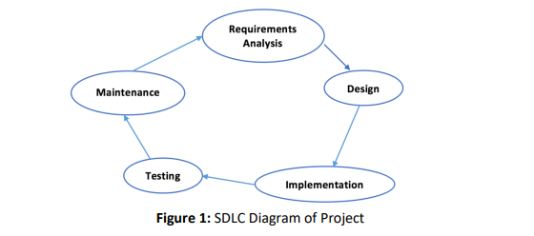

**2.4 FEASIBILITY STUDY**

All projects are feasible when given unlimited resources and infinite time. It is both necessary and prudent to evaluate the feasibility of a project at the earliest possible time. A feasibility study is not warranted for systems in which economic justification is obvious, technical risk is low, few legal problems are expected and no reasonable alternative exists. An estimate is made of whether the identified user needs may be satisfied using current software and hardware technologies. The study will decide if the proposed system will be cost effective from the business point of view and if it can be developed in the given existing budgetary constraints. The feasibility study should be relatively cheap and quick. The result should inform the decision of whether to go ahead with a more detailed analysis.Feasibility study may be documented as a separated report to higher officials of the top-level management and can be included as an appendix to the system specification.

Feasibility and risk analysis is related in many ways. If there is more project risk then the feasibility of producing the quality software is reduced.

***The study is done in these phases***

* Technical feasibility
* Economical feasibility
* Operational feasibility

**2.4.1 TECHNICAL FEASIBILITY**

A study of function, performance and constraints may improve the ability to create an acceptable system. Technical feasibility is frequently the most difficult area to achieve at the stage of product engineering process.

Considering that are normally associated with the technical feasibility include:

* Development risk
* Resource availability
* Technology

**2.4.2 ECONOMICAL FEASIBILITY**

A cost evaluation is weighed against the ultimate income or benefit derived from the developed system or product. Economic feasibility is generally the "bottom-line" consideration that includes cost benefit analysis, long term corporate income strategies, impact on other profit centers or products, cost of resources needed for development and potential market growth. When compared to the advantage obtained from implementing the system its cost is affordable. Also the system is designed to meet the modifications required in the future. So most of the required modifications can be done without much re-work.

Proposed system was developed with the available resources. Since cost input for the software is almost nil the output of the software is always a profit. Hence Software is economically feasible. In the existing system, manpower is more required. In the proposed system, number of employees to be involved is reduced drastically. So, the proposed system is said to be economic In the existing system, storage of the records should be properly done and security should be provided for the records. In the proposed system, the software provides security and maintenance and it hardly needs one or two persons to operate the system.

**2.4.3 OPERATIONAL FEASIBILITY**

Proposed projects are beneficial only if they can be turned into information systems that will meet the organization's operating requirements. Simply stated, this test of feasibility asks if the system will work when it is developed and installed. Are there major barriers to implementation? Here are questions that will help test the operational feasibility of a project: Is there sufficient support for the project from management?Are current business methods acceptable to the users?Have the users been involved in the planning and development of the project?Will the proposed system cause harm?

The purpose of the operational feasibility study is to determine whether the new system will be used if it is developed and implemented. And whether there will be resistance from users that will undermine the possible application benefits.There was no difficulty in, implementing the system and the proposed system is so effective, user friendly and functionally reliable so that the users in the company will find that the new system reduce their hard-steps.If the users of the system are fully aware of the internal working of the system then the users will not be facing any problem in running the system.

**2.5 ANALYSIS MODELING**

Analysis model is operates as a link between the 'system description' and the ‘design model’. In the analysis model, information, functions and the behavior system is defined and these are translated into the architecture, interface and component level design in the 'design modeling'.

***Elements of the analysis model***

**1. Scenario based element**

* This type of element represents the system user point of view.
* Scenario based elements are use case diagram, user stories.

**2. Class based elements**

* The object of this type of element manipulated by the system.
* It defines the object,attributes and relationship.
* The collaboration is occurring between the classes.
* Class based elements are the class diagram, collaboration diagram.

**3. Behavioral elements**

* Behavioral elements represent state of the system and how it is changed by the

external events.

* The behavioral elements are sequenced diagram, state diagram.

**4. Flow oriented elements**

* An information flows through a computer-based system it gets transformed.
* It shows how the data objects are transformed while they flow between the

various system functions.

* The flow elements are data flow diagram, control flow diagram.

**2.4.1 DATA FLOW DIAGRAM**

A DFD is a network that describes the flow of data throughout a system, data stores, and the processes that change, or transform data flows. The DFD network is a formal, logical abstract of a system that may have many possible physical configurations. For this reason, a set of symbols that do not imply a physical form is used to represent data sources, data flows, data transformations and data storage.

The circle or bubble represents a transformation process and the label inside the bubble describes the process, using an active verb. Data flows are directed lines that identify the input data flows and output data flows at each process bubble. Data storage is represented by an open-ended rectangle with a label that identifies the data store or file. The square is labeled to identify an external entity that is a source or destination of a data flow.

***There are four symbols that are used in the drawing of Data Flow Diagrams:***

* **Entities**

External entities represent the source of data that enter the system or the recipients of data that leave the system.

* **Process**

Processes represent activities in which data is manipulated by being stored or retrieved or transformed in some way. A circle represents it. The process will show the data transformation or change.

* **Database**

Databases represent storage of data within the system.

* **Data flow**

A data flow shows the flow of information from its source to its destination. A line represents a data flow, with arrowheads showing the direction of flow

**2.6 SYSTEM SPECIFICATION**

##### 2.6.1 HARDWARE AND SOFTWARE SPECIFICATION

CPU - Core i3 or AMD 3

HARD DISK SPACE - 150 GB or ABOVE

DISPLAY - 15” COLOR MONITOR

MAIN MEMORY - 1 GB

FRONT END - HTML,SCSS,CSS,BOOTSTRAP

BACKEND - JSP

DATABASE - MySQL

WEB BROWSER - GOOGLE CHROME

**2.6.2 SOFTWARE OVERVIEW**

**JSP**

Java Server Pages (JSP) is a server-side programming technology that enables the creation of dynamic, platform-independent method for building Web-based applications. JSP have access to the entire family of Java APIs, including the JDBC API to access enterprise databases.JavaServer Pages often serve the same purpose as programs implemented using the Common Gateway Interface (CGI). But JSP offers several advantages in comparison with the CGI. Performance is significantly better because JSP allows embedding Dynamic Elements in HTML Pages itself instead of having separate CGI files. JSP are always compiled before they are processed by the server unlike CGI/Perl which requires the server to load an interpreter and the target script each time the page is requested. JavaServer Pages are built on top of the Java Servlets API, so like Servlets, JSP also has access to all the powerful Enterprise Java APIs, including JDBC, JNDI, EJB, JAXP, etc. JSP pages can be used in combination with servlets that handle the business logic, the model supported by Java servlet template engines.Finally, JSP is an integral part of Java EE, a complete platform for enterprise class applications. This means that JSP can play a part in the simplest applications to the most complex and demanding.

##### MySQL

This is a powerful relational database management system containing modifiable source code. It is the most preferable option for Linux users due to its robust, swift, and reliable structure. This is also a very fast and reliable database management system. The vendor of this database is Microsoft, and the database provides fast access to developers who are working on a Windows platform. . The software is compatible with both Windows and Linux platforms. MySQL is a relational database management system that provides the facility to manage databases.

##### ***Features***

MySQL also provides the following features:

* Support for languages such as Perl, Python, and PHP
* Support for a thread-based memory allocation system (Therefore, it is quite fast)
* Support for fixed as well as variable length records
* Support for a host-based verification system that provides security through verifying
* Passwords that are encrypted during transit
* Support for large databases

**SYSTEM DESIGN**

**3. SYSTEM DESIGN**

System Design is the process of developing specifications for a candidate system that meet the criteria established in the system analysis. Major step in system design is the preparation of the input forms and the output reports in a form applicable to the user.

The main objective of the system design is to use the package easily by any computer operator. System Design is the creative act of invention, developing new inputs, a database, offline files, method, procedures and output for processing business to meet an organization objective. System design builds information gathered during the system analysis.

Input design is the process of converting the user-originated inputs to a computer-based format. The design for handling input specifies how data are accepted for computer processing. Input design is a part of overall system design that needs careful attention and if includes specifying the means by which actions are taken.

A system user interacting through a workstation must be able to tell the system whether to accept input produce a report or end processing. The collection of input data is considered to be the most expensive part of the system design. Since the inputs have to be planned in such a manner so as to get the relevant information extreme care is taken to obtain the information. If the data going into the system is incorrect then the processing and outputs will magnify these errors.

The output design has been done so that the results of processing should be communicated to the user. Effective output design will improve the clarity and performance of outputs. Output is the main reason for developing the system and the basis on which they will evaluate the usefulness of the application.

Output design phase of the system is concerned with the Convergence of information to the end user - friendly manner. The output Design should be efficient, intelligible so that system relationship with the end user is improved and thereby enhancing the process of decision making

**3.1 OUTPUT DESIGN**

Designing computer output should proceed in an organized, well thought manner; the right output must be developed. While ensuring that each output elements is designed so that people will find the system easy to use effectively. The output from an information system should accomplish one or more of the following objectives

Outputs are the most important and direct source of information to the user and to the department. Intelligent output design will improve the systems relationship with the user and help much in decision-making. Outputs are also used to provide a permanent hard copy of the results for later uses. The forms used in the system are shown in the appendix. The Output Design is another very important phase. The outputs are mainly used to communicate with a user, processing the input data given by the user etc

* Convey information about past activities, current status or projection of the future.
* Signal important events, opportunities, problems or warning.
* Trigger an action.
* Confirm an action

**3.2 INPUT DESIGN**

The first step in the design is the input and the output within predefined guidelines. In the input design, user organized input are converted to a computer based format. It also includes determining the media, method of input, speed of capture an entry in to the system. The collection of input data is the most expensive part of the system in terms of the equipment used and the number of people involved. In input design, data is accepted for computer processing and input to the system is done through mapping via some map support or links. In accurate input data is the most common cause of errors in data processing. The input screens need to be designed very carefully and logically. A set of menus is provided which help for better application navigation. While entering data in the input forms, proper validation checks are done and messages will be generated by the system if incorrect data has been entered.

##### *Input Design Objectives:*

* To produce a cost effective method of input.
* To achieve the high level of accuracy.
* To ensure that the input is acceptable to and understand by the user

**3.3 DATABASE DESIGN**

The most important aspect of building an application is the design of database. The data they store must be organized according to the user requirement. A well designed database is essential for the good performance of the system. A database table known as a relation provides information related to specific entity.

A database is a collection of interrelated data stored with minimum redundancy to serve many users quickly and efficiently. The overall objective in the development of the database technology has been to treat data as an organizational resource and as an integrated whole. Database management system allows the data to be protected and organized separately from other resources. The general objective is to make information access, easy, quick, inexpensive and flexible for the user.

Database files are the key source of information into the system. The files should be properly designed and planned for collection, accumulation, editing and retrieving the required information. This database contains tables, where each table corresponds to one particular type of information. Each piece of information in the table called field or column. A table also contains records, which is a set of fields. All records in a table have the same set of fields with different information. There are primary key fields that uniquely identify a record table.

***The main objectives of database design are:-***

* Data Integration.
* Data Integrity.
* Data independence

**3.3.1 TABLE STRUCTURE**

**DATABASE NAME:** onlinequiz

**1.Table Name :** user

**Description:** - Adding users

**Primary Key**  : - user_id

**Foreign Keys** : dep_id ,type_id

|  |  |  |  |  |
| --- | --- | --- | --- | --- |
| **FIELD NAME** | **DATA TYPE** | **SIZE** | **CONSTRAINTS** | **EXTRA** |
| user_id | Int |  | PRIMARY KEY | AUTO-INCREMENT |
| name | Varchar | 150 | NOT NULL |  |
| dep_id | Int |  | NOT NULL |  |
| email | Varchar | 150 | NOT NULL |  |
| type_id | Int |  | NOT NULL |  |
| password | Varchar | 150 | NOT NULL |  |
| status | Int |  | NOT NULL |  |

**2.Table Name :** user_type

**Description:** - Type of the users

**Primary Key** : -type_id

|  |  |  |  |  |
| --- | --- | --- | --- | --- |
| **FIELD NAME** | **DATA TYPE** | **SIZE** | **CONSTRAINTS** | **EXTRA** |
| type_id | Int | 10 | PRIMARY KEY | AUTO-INCREMENT |
| type_name | Varchar | 50 | NOT NULL |  |

**3.Table Name :** department

**Description: -** Department Details

**Primary Key : -** dep_id

|  |  |  |  |  |
| --- | --- | --- | --- | --- |
| **FIELD NAME** | **DATA TYPE** | **SIZE** | **CONSTRAINTS** | **EXTRA** |
| dep_id | Int |  | PRIMARY KEY | AUTO-INCREMENT |
| name | Varchar | 50 | NOT NULL |  |
| status | Varchar | 15 | NOT NULL |  |

**4.Table Name :** subject

**Description**: - Subject Details

**Primary Key : -** sub_id

**Foreign Keys** : dep_id

|  |  |  |  |  |
| --- | --- | --- | --- | --- |
| **FIELD NAME** | **DATA TYPE** | **SIZE** | **CONSTRAINTS** | **EXTRA** |
| sub_id | Int |  | PRIMARY KEY | AUTO_INCREMENT |
| sub_name | Varchar | 40 | NOT NULL |  |
| dep_id | Int |  | NOT NULL |  |
| status | Int |  | NOT NULL |  |

**5.Table Name :** question

**Description**: - Question Details

**Primary Key : -** q_id

**Foreign Keys** : sub_id

|  |  |  |  |  |
| --- | --- | --- | --- | --- |
| **FIELD NAME** | **DATA TYPE** | **SIZE** | **CONSTRAINTS** | **EXTRA** |
| q_id | Int |  | PRIMARY KEY | AUTO_INCREMENT |
| que_name | Varchar | 40 | NOT NULL |  |
| sub_id | Int |  | NOT NULL |  |

**6.Table Name :** answer

**Description**: - Answer Details

**Primary Key : -** ans_id

**Foreign Keys** : q_id

|  |  |  |  |  |
| --- | --- | --- | --- | --- |
| **FIELD NAME** | **DATA TYPE** | **SIZE** | **CONSTRAINTS** | **EXTRA** |
| ans_id | Int |  | PRIMARY KEY | AUTO_INCREMENT |
| answer | Varchar | 40 | NOT NULL |  |
| answer1 | Varchar | 40 | NOT NULL |  |
| answer2 | Varchar | 40 | NULL |  |
| answer3 | Varchar | 40 | NULL |  |
| q_id | Int |  | NOT NULL |  |

**7.Table Name :** score

**Description**: - Score Details

**Primary Key : -** s_id

**Foreign Keys** : sub_id

|  |  |  |  |  |
| --- | --- | --- | --- | --- |
| **FIELD NAME** | **DATA TYPE** | **SIZE** | **CONSTRAINTS** | **EXTRA** |
| s_id | Int |  | PRIMARY KEY | AUTO_INCREMENT |
| score | Int |  | NOT NULL |  |
| sub_id | Int |  | NOT NULL |  |

**3.4 MODULE DESCRIPTION**

* **ADMIN**

In this module administrator can view,update,delete users/department/subject and rollback the deleted users.

* **TEACHER**

In this module teacher can add questions and answers and view the score of the students.

* **STUDENT**

In this module student can attempt quiz of the desired subjects and view score of each subjects he/she attempted quiz.

**SYSTEM TESTING**

**AND**

**IMPLEMENTATION**

**4. SYSTEM TESTING AND IMPLEMENTATION**

Implementation of system testing automatization on computer aided systems for hardware and software. System testing is considered to be a crucial step in quality management process that enables testers to verify and validate the application and architecture as well as the requirements

**4.1 SYSTEM TESTING**

System testing is an activity to check weather the actual results match the expected results and to ensure that the software system defect free .It involves execution of a software component or system component to evaluate one or more properties interest . Software testing also helps to identify errors , gaps or missing requirements in contrary to the actual requirements. It can be either done manually using automated tools.

***Typically testing is classified into 3 categories***

* Functional testing
* Non-functional / Performance
* Maintenance testing

***Functional testing can be further divided into***

* Unit Testing
* Integration Testing
* Final/ System testing

**4.1.1 UNIT TESTING**

Here each module is test individually and integrate the overall system. Unit testing focuses verification efforts even in the smallest unit of software design in each module. This is known as “Module Testing”. The modules of the system are tested separately. This testing is carried out in the programming style itself. In this testing each module is focused to work satisfactorily as regard to expected output from the module. There are some validation checks for the fields.

**4.1.2 INTEGRATION TESTING**

Data can be lost across an interface, one module can have an adverse effect on the other sub-functions, when combined may not produce the desired functions. Integrated testing is the systematic testing to uncover the errors within the interface. This testing is done with simple data and the developed system has run successfully with this simple data. The need for integrated system is to find the overall system performance.

**4.1.3 SYSTEM TESTING**

When a system is developed, it is hoped that it performs properly. In practice, however, some errors always occur. The main purpose of testing an information system is to find the errors and correct them. A successful test is one, which finds an error.

***The main objectives of system testing are***

* To ensure during operation the system will perform as per specification.
* To make sure that the system meets user’s requirements during operation.
* To verify that the controls incorporated in the system function as intended.
* To see that when correct inputs are fed to the system the outputs are correct.
* To make sure that during operation, incorrect input and output will be deleted.

The scope of a system test should include both manual operations and computerized.

**4.2 SYSTEM IMPLEMENTATION**

It includes actual programming, testing, training, and use if the new system. Upon completion of the system, the analyst, users and management evaluate the system to ensure that if fulfill all its goals. Implementation is the third phase in the system process.

Implementation involves the conversion of the basic application into a complete replacement with a computer system. It is the process of converting a new system design into a operational one. Implementation process is simply a translation of the design into a physical realization, using the language of the target architecture. The proposed system may totally new, replacing an existing manual system of it major modification of the existing system. In either case, proper implementation is essential to provide a reliable system to meet the user requirements.

Implementation is the stage of the project when the theoretical design is turned into a working system. The implementation stage is systems project in its own right. It includes careful planning, investigation of current system and its constraints on implementation, design of methods to achieve the changeover, training of the staff in the changeover procedure and evaluation of changeover method.

The first task in implementation is planning-deciding on the methods and time-scale to be adopted. Once the planning has been completed, the major effort is to ensure that the programs in the system are working properly. At the same time concentrate on training the staff. When the staffs have been trained, the complete system, involving both computer and user can be executed effectively.

When the Managers system is linked to terminals on remote sites, the telecommunication network and tests of the network along with the system are also included under implementation. Depending upon the nature of the system, extensive user training may be required. Programming itself is a design work.

The initial parameters of the management information system should be modified as a result of programming efforts; programming provides a Reality test for the assumptions made by the analyst.

System testing check the readiness and accuracy of the system access update and retrieve data from new files. One the program becomes available; the test data are read into the computer and processed. In this system, conventional Parallel Run was conducted to establish the efficiency of the system. Implementation is used here to mean the process of converting a new or a revised system design into an Operational one. Conversion is one aspect of Implementation.

##### CONVERSION

Conversion means changing from one system to another. The objective is to put the tested system into operation while holding costs, risks, and personal irritation to minimum involves- Creating Computer-Compatible Files, Training the Operating Staff and Installing Terminals and Hardware.

##### CHANGEOVER METHOD

Changeover is the process of adopting the new system. The new system has to be introduced however. This is done after the system has been developed and tested completely. There is a set of methods like Direct Changeover, Parallel Changeover, Pilot running etc. Pilot running is intended here. Data from one or more previous periods for the whole or part of the system is run on the new system after results have been obtained from the old system and both are compared. It is performed till the completion of one system life cycle.

When the changeover has taken place there will be a needed for amendment to correct or improve the new system. When the user wants to add any new records, some fields will automatically get their default values. If the user desired to change these default values he can do it.

The implementation view of software requirements presents the real world manifestation of processing functions and information structures. The implementation model represents the current mode of operations, that is, the existing or proposed allocation for all system elements.

In this phase a prototype is constructed or customer and developer assessment. The model is the only means through which requirements can be effectively derived. The model then involves into production software. For software prototyping, three generic classes of methods and tools are available: fourth generation techniques, reusable software components, formal specification and prototyping environment.

Fourth generation techniques encompass a broad array of database query and reporting languages, program and application generators and other very high level nonprocedural languages.

Because 4GT enable the software engineer to generate executable code quickly, they are ideal for rapid prototyping.Another approach to rapid prototyping is to assemble, rather to build, the prototype by using a set of existing software components. A software component may be a data structure of database of a software architectural component or a procedural in a manner that enables it to be reused without detailed knowledge of its internal workings.Over the past two decades, a number of formal specification languages and tools have been developed as a replacement for natural languages specification techniques

### **4.3 SYSTEM SECURITY**

Data from one or more previous periods for the whole or part of the system is run on the new system after results have been obtained from the old system and both are compared. It is performed till the completion of one system life cycle.

When the changeover has taken place there will be a need for amendment to correct or improve the new system. When the user wants to add any new records, some fields will automatically get their default values. If the user desires to change these default values he can do it

**FUTURE ENHANCEMENT**

**5. FUTURE ENHANCEMENT**

As mentioned the project is on java platform which is coded in NetBeans IDE with help HTML, SCSS and JavaScript and running as web page by Glassfish web server. But this project is only for MCQ test but in the future we have plan to extended it to support subjective type of questions with more functionality. We will add Administrative part on it which able the system to delete test, add user, delete user and so on graphically vie the web.

**CONCLUSION**

**6. CONCLUSION**

To conclude, this is a simple Online MCQ Quiz which able a teacher to punch MCQ question to system which will be store in SQL Server database and able the student to attempt any test for once. The marks of student will be calculated according to questions they attempt and will be displayed by the system to teachers and student.

**APPENDIX**

1. **DATAFLOW DIAGRAM**

**LEVEL 0**

**CONTEXT LEVEL**

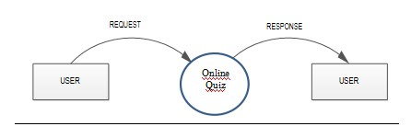

**LEVEL 1**

**LOGIN**

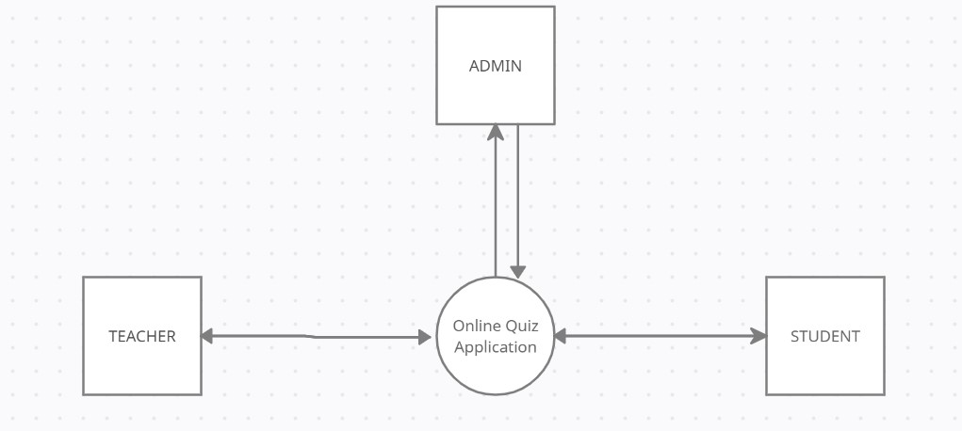

**LEVEL 2.1**

**ADMIN**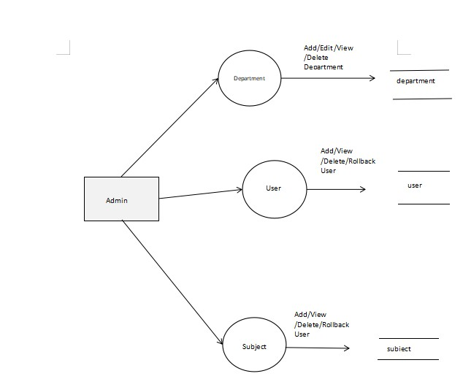

**LEVEL 2.2**

**TEACHER**

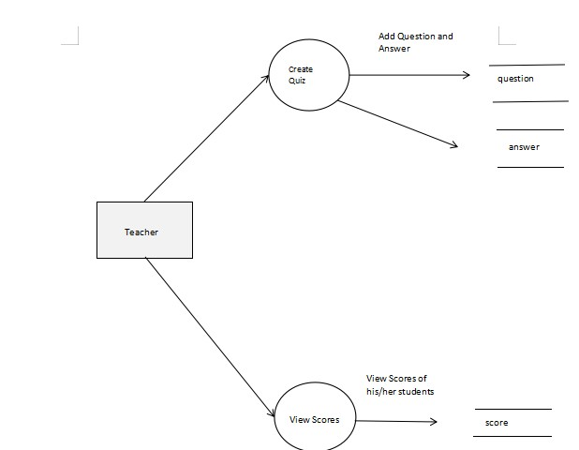

**LEVEL 2.3**

**STUDENT**

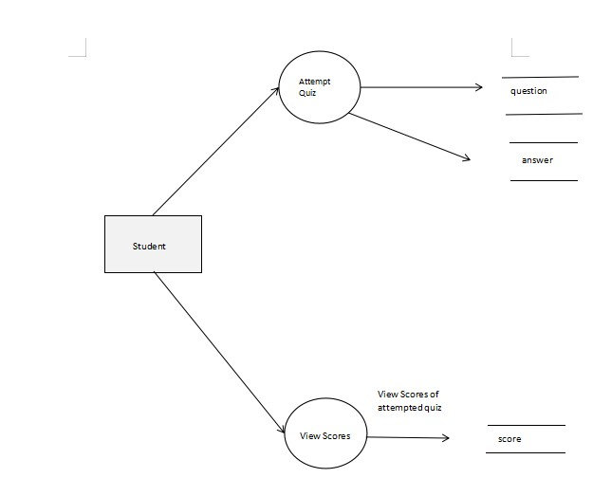

**B. CODING**

**Login Page**

<jsp:useBean class="DataBase.ConnectionClass" id="obj"></jsp:useBean>

<%@page import="java.sql.ResultSet" %>

<%@page import="java.sql.ResultSet" %>

<%@page import="java.sql.*" %>

<%@page import="java.util.*" %>

<%@page import="java.io.*" %>

<%

String un = request.getParameter("email");

String ps = request.getParameter("password");

if (request.getParameter("submit") != null) {

String sQ1 = "select *from user a inner join user_type b on a.type_id = b.type_id Where ( email = '" + un + "' and password = '" + ps + "' ) and ( b.type_name = 'Admin' And status='1')";

String sQ2 = "select *from user a inner join user_type b on a.type_id = b.type_id Where ( email = '" + un + "' and password = '" + ps + "' ) and ( b.type_name = 'Teacher' And status='1')";

String sQ3 = "select *from user a inner join user_type b on a.type_id = b.type_id Where ( email = '" + un + "' and password = '" + ps + "' ) and ( b.type_name = 'Student' And status='1')";

ResultSet rs1 = obj.select(sQ1);

ResultSet rs2 = obj.select(sQ2);

ResultSet rs3 = obj.select(sQ3);

if (rs1.next()) {

String user_id = rs1.getString("user_id");

session.setAttribute("sid", user_id);

response.sendRedirect("Admin/pages/virtual-reality.html");

}

if (rs2.next()) {

String user_id = rs2.getString("user_id");

session.setAttribute("sid", user_id);

response.sendRedirect("index_teacher.jsp");

}

if (rs3.next()) {

String adid = rs3.getString("user_id");

session.setAttribute("sid", adid);

response.sendRedirect("index_student.jsp");

}

}

%>

<!DOCTYPE html>

<!--

To change this license header, choose License Headers in Project Properties.

To change this template file, choose Tools | Templates

and open the template in the editor.

-->

<html>

<head>

<title>Login Page</title>

<!--Bootsrap 4 CDN-->

<link rel="stylesheet" href="https://stackpath.bootstrapcdn.com/bootstrap/4.1.3/css/bootstrap.min.css" integrity="sha384-MCw98/SFnGE8fJT3GXwEOngsV7Zt27NXFoaoApmYm81iuXoPkFOJwJ8ERdknLPMO" crossorigin="anonymous">

<!--Fontawesome CDN-->

<link rel="stylesheet" href="https://use.fontawesome.com/releases/v5.3.1/css/all.css" integrity="sha384-mzrmE5qonljUremFsqc01SB46JvROS7bZs3IO2EmfFsd15uHvIt+Y8vEf7N7fWAU" crossorigin="anonymous">

<link href="//maxcdn.bootstrapcdn.com/bootstrap/4.1.1/css/bootstrap.min.css" rel="stylesheet" id="bootstrap-css">

<script src="//maxcdn.bootstrapcdn.com/bootstrap/4.1.1/js/bootstrap.min.js"></script>

<script src="//cdnjs.cloudflare.com/ajax/libs/jquery/3.2.1/jquery.min.js"></script>

<!------ Include the above in your HEAD tag ---------->

<!--Custom styles-->

<link rel="stylesheet" type="text/css" href="login.css">

</head>

<body>

<div class="container">

<div class="d-flex justify-content-center h-100">

<div class="card">

<div class="card-header">

<h3>Sign In</h3>

<div class="d-flex justify-content-end social_icon">

<span><i class="fab fa-facebook-square"></i></span>

<span><i class="fab fa-google-plus-square"></i></span>

<span><i class="fab fa-twitter-square"></i></span>

</div>

</div>

<div class="card-body">

<form method="post">

<div class="input-group form-group">

<div class="input-group-prepend">

<span class="input-group-text"><i class="fas fa-user"></i></span>

</div>

<input type="text" class="form-control" placeholder="username" name="email">

</div>

<div class="input-group form-group">

<div class="input-group-prepend">

<span class="input-group-text"><i class="fas fa-key"></i></span>

</div>

<input type="password" class="form-control" placeholder="password" name="password">

</div>

<div class="row align-items-center remember">

<input type="checkbox">Remember Me

</div>

<div class="form-group">

<input type="submit" name="submit" id="submit" class="btn float-right login_btn">

</div>

<div class="row align-items-center remember">

<a href="index.jsp"> Home </a>

</div>

</form>

</div>

<div class="card-footer">

<div class="d-flex justify-content-center links">

Don't have an account?<a href="reg.jsp">Sign Up</a>

</div>

<div class="d-flex justify-content-center">

<a href="#">Forgot your password?</a>

</div>

</div>

</div>

</div>

</div>

</body>

</html>

**C.SCREENSHOT**

**HOME PAGE**

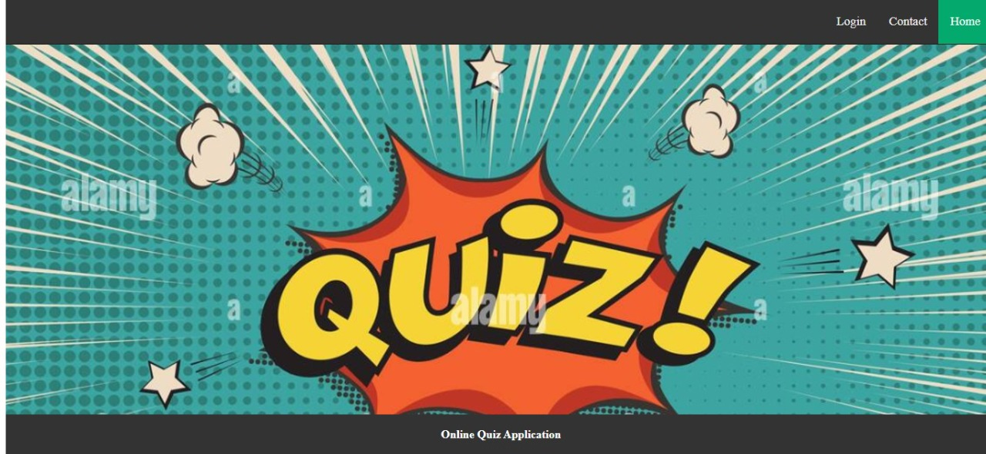

**USER LOGIN**

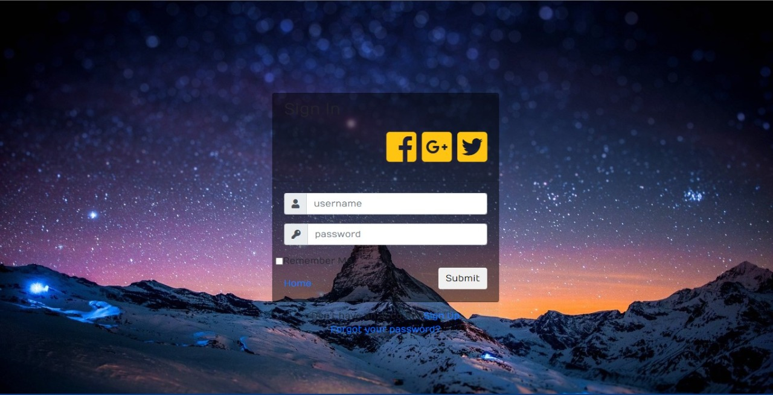

**ADMIN DASHBOARD**

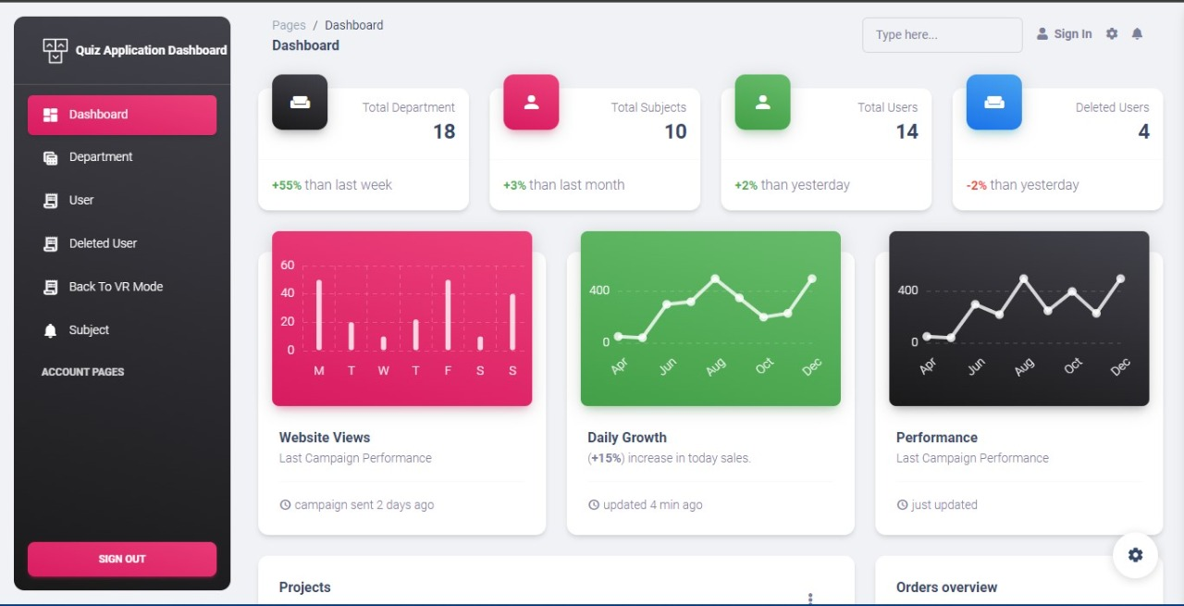

**TEACHER DASHBOARD**

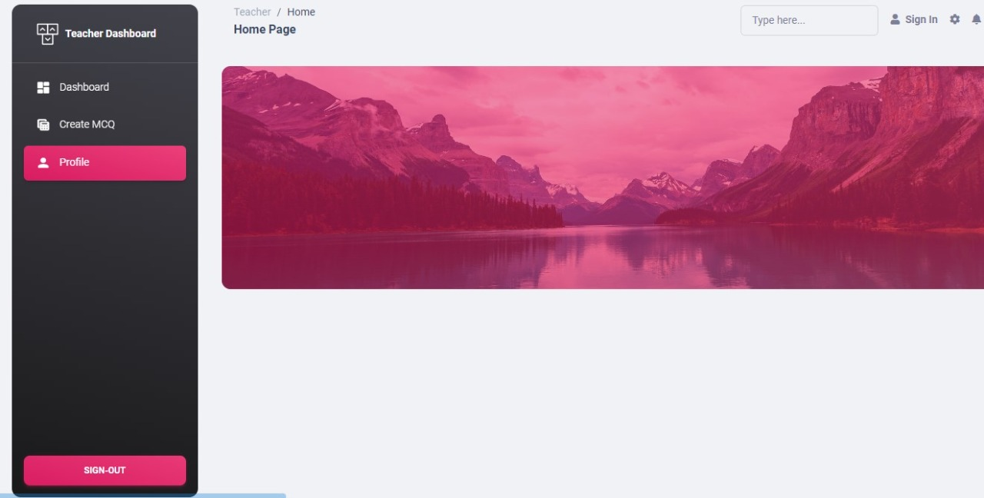

**STUDENT DASHBOARD**

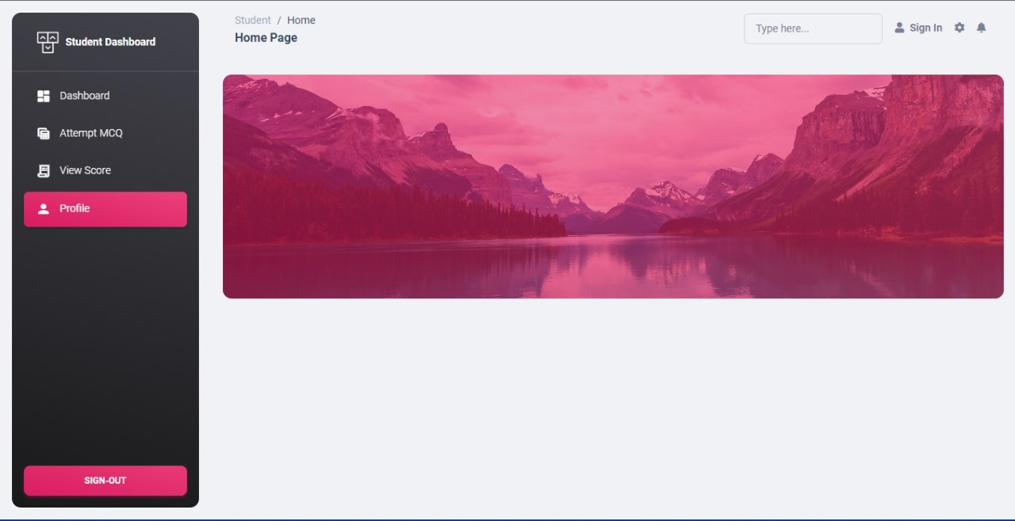

**ATTEMP MCQ PAGE**

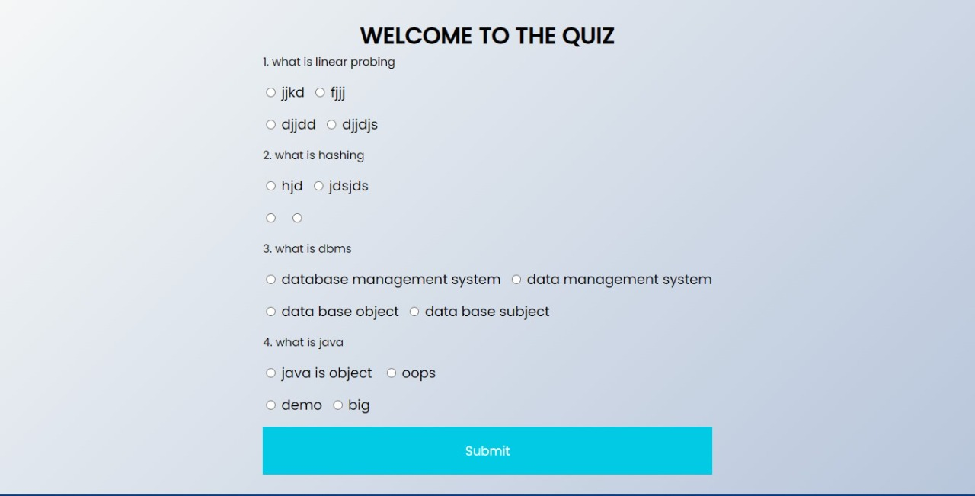

**BIBLIOGRAPHY**

**BIBLIOGRAPHY**

**References:**

[1]Patil,PratekandKarlMoss,2017,JavaDatabaseProgrammingwithJDBC,

[2]http://www.javaworld.com/

[3] <http://jdbc-tutorial.com/>